SALESTORM: A Scalable and Reliable Flash-Sale E-Commerce Platform

INTRODUCTION
*SALESTORM* is a high-scale e-commerce flash-sale platform designed to handle a large number of customers competing for a limited quantity of products. The system focuses on maintaining *scalability, reliability, performance, and data consistency* during sudden traffic spikes. Its core objective is to prevent *inventory overselling* while safely managing product reservations, checkout, payments, orders, shipments, and notifications. The architecture uses *microservices, caching, asynchronous messaging, database persistence, and fault-tolerance mechanisms* to provide a reliable and scalable shopping experience.

OBJECTIVES
- To design a scalable flash-sale platform capable of handling thousands of concurrent customer requests.
- To prevent inventory overselling by implementing safe inventory reservation and concurrency control.
- To provide reliable payment processing with idempotency, timeout handling, and reconciliation.
- To maintain data consistency across inventory, reservations, payments, and orders.
- To ensure high availability and fault tolerance using retries, circuit breakers, message queues, and failure recovery.
- To enable independent service scaling through a microservice-based architecture.
- To provide secure and observable operations using authentication, API protection, monitoring, logging, and tracing.
- To build a maintainable system using SOLID principles and suitable design patterns.

REQUIREMENTS OF SALESTORM
- FUNCTIONAL REQUIREMENTS

- User Management – Customer registration, login, and profile management.
- Product Management – Browse products and manage product information.
- Cart Management – Add, update, and remove products from the shopping cart.
- Flash-Sale Management – Manage sale price, sale duration, and limited stock.
- Inventory Management – Track available stock and prevent negative inventory.
- Inventory Reservation – Temporarily reserve products before payment.
- Checkout – Validate cart, product availability, address, and order details.
- Payment Processing – Process payments through an external payment gateway.
- Order Management – Create and track orders after successful payment.
- Shipment Management – Create shipments and track delivery status.
- Notification Management – Send email, SMS, or push notifications.
- Failure Handling – Handle payment failures, timeouts, duplicate requests, and reservation expiry.
- Admin Management – Manage products, inventory, orders, shipments, and system operations.
2. NON-FUNCTIONAL REQUIREMENTS
- Scalability – Support approximately 10,000 concurrent requests during flash sales.
- Performance – Provide fast responses during sudden traffic spikes.
- Availability – Keep the system available even when individual services fail.
- Reliability – Recover safely from payment, network, and service failures.
- Consistency – Ensure inventory, payment, reservation, and order data remain consistent.
- Security – Protect customer data and transactions using authentication, authorization, HTTPS/TLS, and API protection.
- Fault Tolerance – Use retries, timeouts, circuit breakers, message queues, and failure recovery.
- Maintainability – Use modular services, SOLID principles, and design patterns.
- Observability – Provide logging, monitoring, metrics, tracing, and alerts.
- Data Integrity – Ensure stock is not oversold and transactions are not duplicated or lost.

ARCHITECTURE DIAGRAM
System Context Architecture

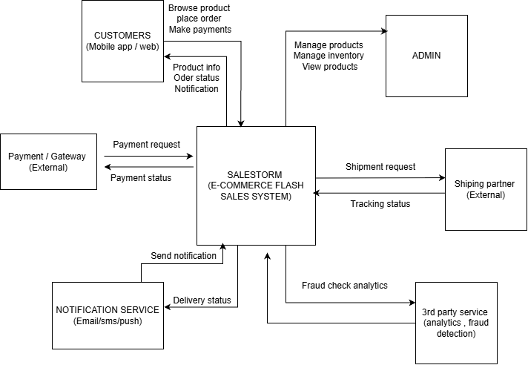

High Level Architecture
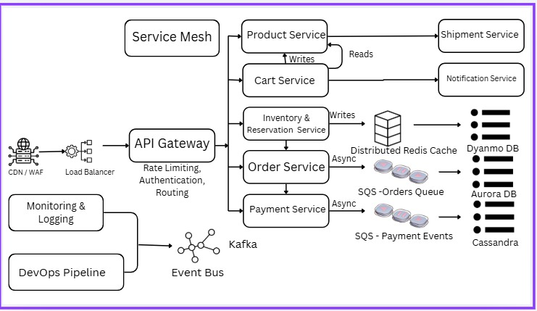

Container Diagram
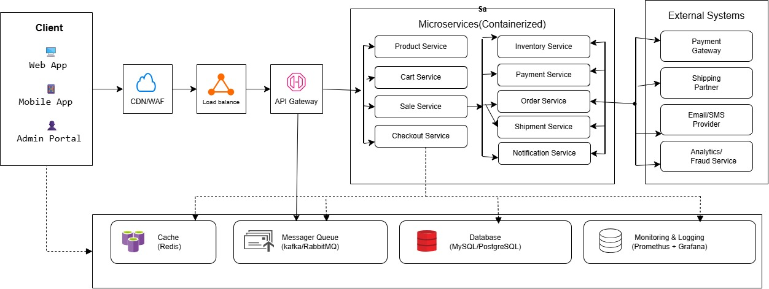
Component Diagram
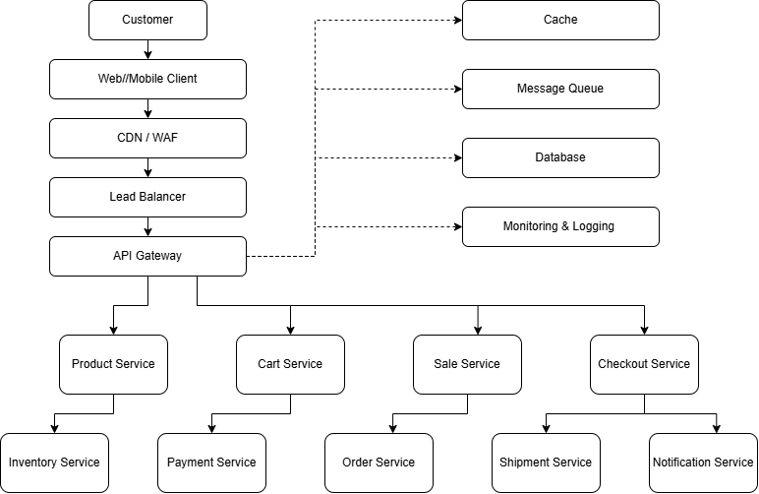

Deployment Diagram
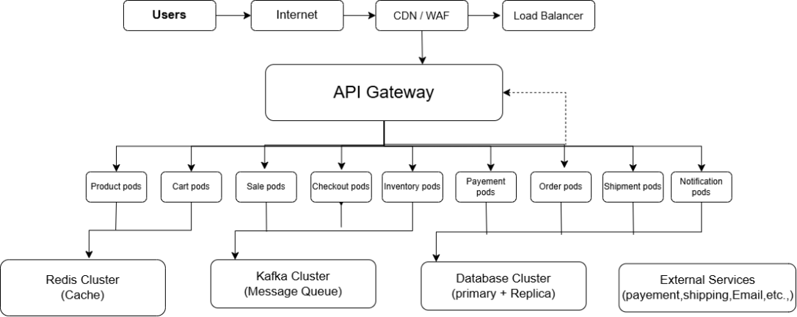

ER Diagram
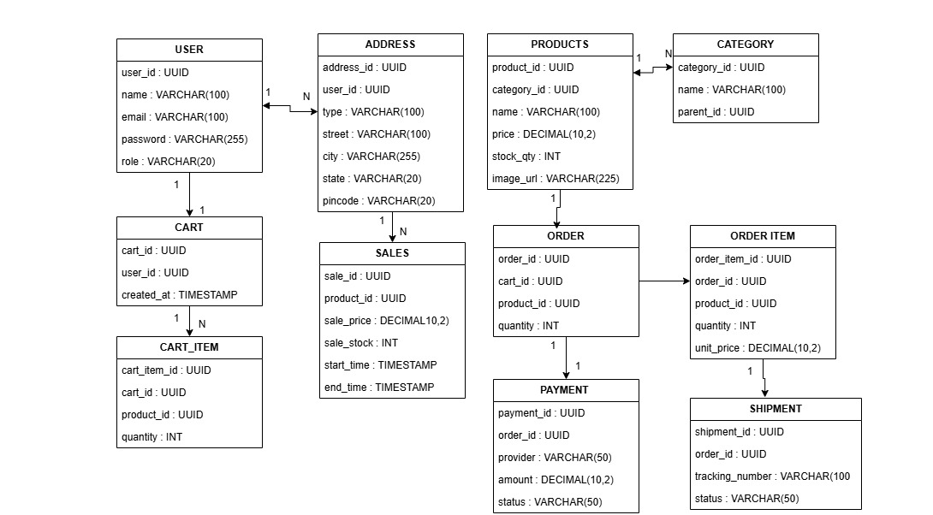
SEQUENCE DIAGRAM
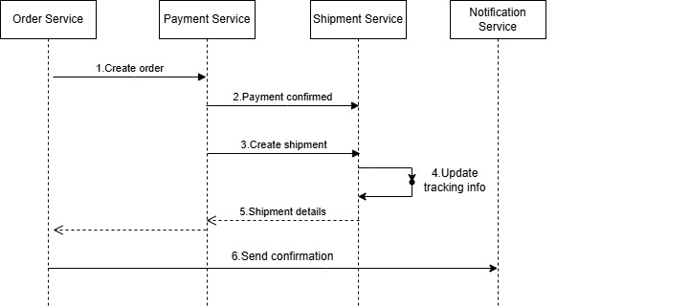

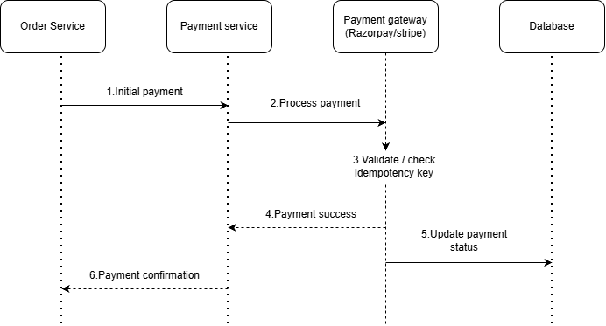
SOLID PRINCIPLES

- S – Single Responsibility: Separate Inventory, Payment, and Order services.
- O – Open/Closed: Add new payment methods without changing existing code.
- L – Liskov Substitution: Payment providers should be interchangeable.
- I – Interface Segregation: Use separate interfaces for payment, shipping, and notifications.
- D – Dependency Inversion: Depend on interfaces instead of specific implementations.

DESIGN PATTERNS\

- Strategy Pattern: Supports different payment methods like UPI, cards, and net banking.
- Factory Pattern: Creates the required payment processor.
- State Pattern: Manages order and reservation states.
- Observer Pattern: Sends notifications when order status changes.
- Adapter Pattern: Connects external payment gateways to the system.
- Repository Pattern: Handles database operations.
- Circuit Breaker Pattern: Prevents repeated calls to a failing payment service.

SCALABILITY

- Horizontal Scaling: Add more servers to handle high traffic.
- Load Balancing: Distribute requests across multiple servers.
- Caching: Use Redis to access product data quickly.
- Message Queue: Process orders and notifications asynchronously.
- Database Scaling: Use replication and partitioning to manage large amounts of data.
- Auto-scaling: Automatically increase servers during flash sales.

RELIABILITY AND FAILURE RECOVERY
- Retry Mechanism: Retry failed requests safely.
- Idempotency: Prevent duplicate payments and orders.
- Circuit Breaker: Stop repeated calls to failed services.
- Message Queue: Store events and retry failed processing.
- Reservation Timeout: Release stock when payment fails or expires.
- Backup and Recovery: Restore data after database failures.
- Monitoring and Alerts: Detect failures and notify administrators.

SECURITY
- Authentication: Secure user login using JWT or sessions.
- Authorization: Allow access based on user roles.
- HTTPS Encryption: Protect data during transmission.
- Rate Limiting: Prevent excessive requests during flash sales.
- Input Validation: Block invalid and malicious inputs.
- Secure Payments: Protect payment details and prevent duplicate transactions.
- Data Protection: Encrypt sensitive data and manage secrets securely.
- WAF Protection: Block malicious traffic and common web attacks.

OBSERVABILITY
- Monitoring: Track system performance and server health.
- Logging: Record errors, payments, and order activities.
- Distributed Tracing: Track requests across multiple services.
- Alerts: Notify administrators about failures.
- Metrics: Monitor response time, traffic, payment failures, and inventory status.

